Modeling Challenge Based Learning
Skills Workshop # 2

Speaker: Kelly Lindsey, Teacher, Boone County High School
Date: Thursday, June 11, 2019
Time: 2:30-5:00 PM
Venue: University of Cincinnati, Baldwin Hall, room 741

Prepared by:
Ramya Ravindrababu, Betsy Layne High School, Stanville, Kentucky
RET Participant for Project #2: Energy Storage Devices for Wearable Electronics.

This session was given by Kelly Lindsey, who has been teaching since 1981. Ms. Lindsey graduated from Campbellsville University in Campbellsville, KY with a degree in mathematics and music education. Her first teaching job was in Nigeria where she taught math, physics and music in a boarding school for Nigerian students. After returning to the United States she taught in Kentucky and got her MAE in mathematics from Western KY University. Since then she has taught in Virginia, Maryland, and Kentucky with experience at all levels of education from Pre-K through University. Currently, she teaches math at Boone County High School in Florence, KY and serves as the Math Team Leader.

Ms. Lindsey began the session by introducing Challenge Based Learning. Challenge Based Learning (CBL) is a pedagogic approach developed for K-12 teachers by Apple Inc. She described the process of leading students through the discovery and creation process by connecting content to real world problems. The value of this approach is that students are forced to “do” something – Ms. Lindsey described the increased engagement for students and teachers created by the (CBL) process. See Ms. Lindsey in Figure 1 discussing the benefits and goals of CBL.

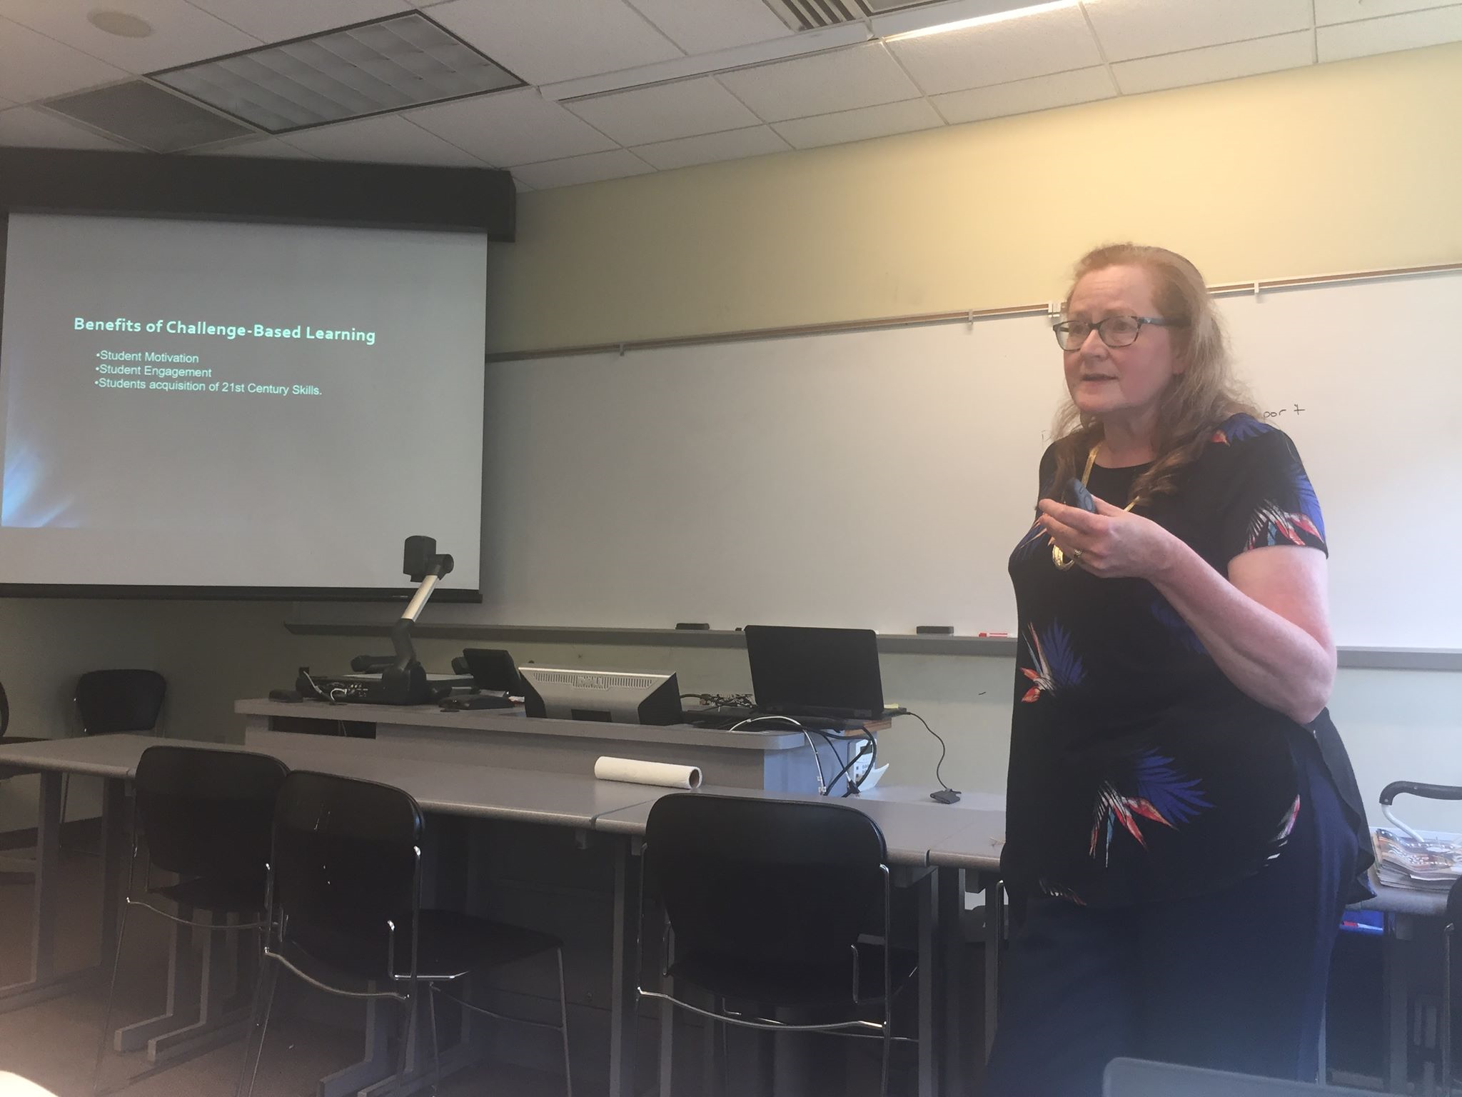 | 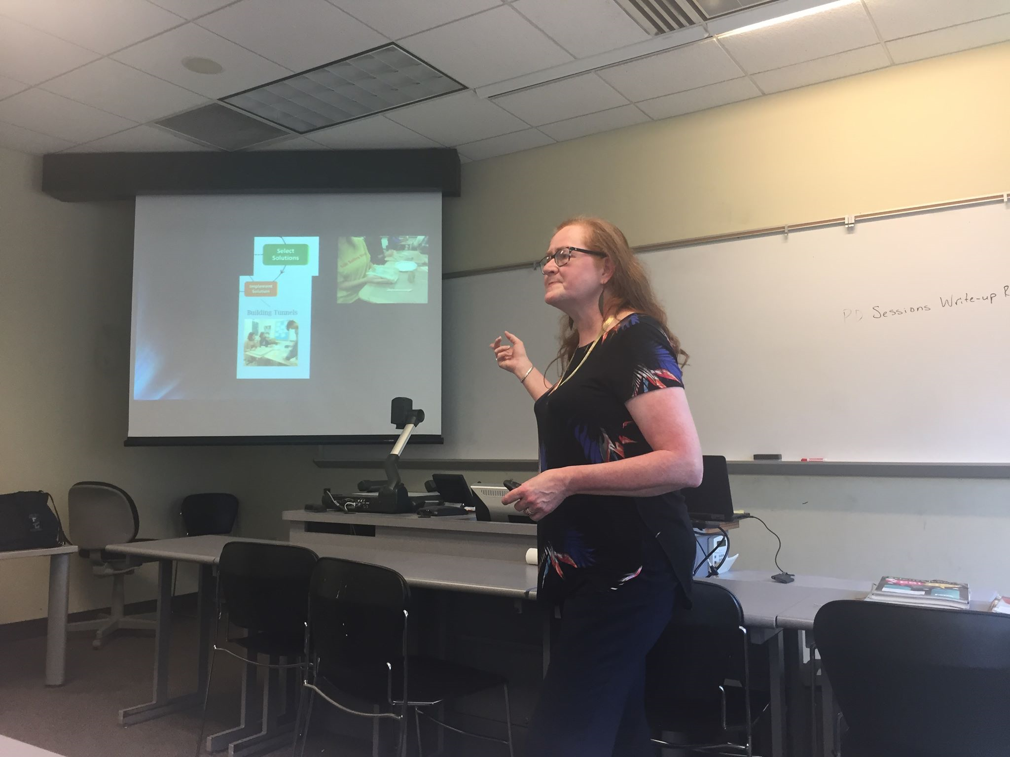
Figure 1: Ms. Lindsey describing benefits of Challenge Based Learning | Figure 2: Students evaluate solutions using Desmos calculators

To describe the full process of Challenge Based Learning, Ms. Lindsey walked the RET participants through the CBL unit she had implemented in her Advanced Algebra class. The “Big Idea” represents the Unit in which the CBL occurs, in her classroom this was the unit relating Algebraic functions with real world construction, specifically tunnels. First, her students researched tunnels and watched videos about the Cincinnati subway, the Laerdal tunnel in Norway (the longest land-based tunnel). Figure 2 shows her class used Desmos calculators and clay to evaluate and implement their tunnel ideas. Her students were given 3 days to build their tunnels.

Students reactions to the Challenge Based Learning project were varied. Students experienced various degrees of success. She noted that often-times for children who were accustomed to success in math class, this project may be the first time they experience frustration. She discussed strategies for reframing challenges in the project, tunnels breaking, scale issues, etc., as engineering learning opportunities. Failure is part of the engineering process, she explained. Students need to be able to understand this idea. Ms. Lindsey emphasized the importance of getting students to understand and talk about what modifications and improvements they could make to their existing models. Some students who experienced the most success with the project were students who may not have experienced much success in a math class before. Ms. Lindsey explained that projects like these are valuable because they allow students who may never see themselves as “good at math” to experience success and accomplishment.

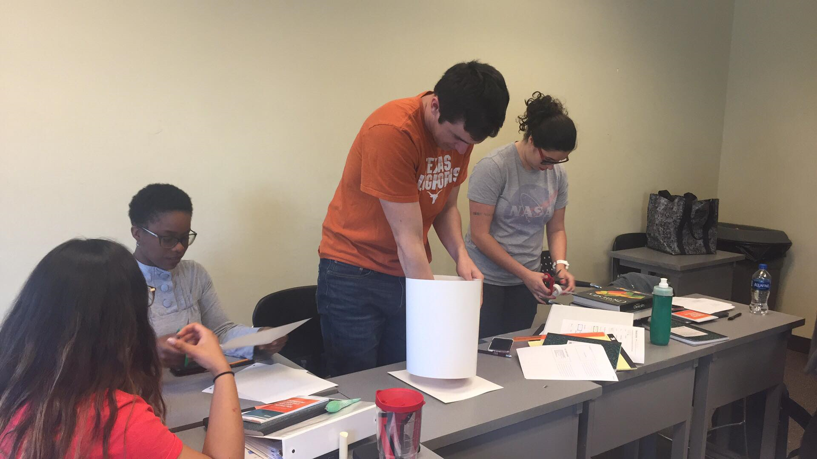

Figure 3: Building a Platform

Ms. Lindsey concluded her presentation by demonstrating the beginnings of a Challenge Based Learning lesson to the RET class. Ms. Lindsey introduced the “Problem” – creating an 11-inch platform for textbooks within 20 minutes using only 1 poster board, 3 sheets of paper, 1 roll of tape, 1 coffee stirrer, & 4 sticks of gum. Figure 3 shows the one of the RET groups working on their platform. The challenge is to construct a platform that will hold significant weight using materials that are relatively flimsy on their own. Later, the RET participants tested their models using textbooks. Both group’s models managed to balance 10 textbooks. The models were then tested using desks and other objects to see which design held up the best. It was all part of the fun of the engineering process!

